
Touchstones
Netcards

Kindness Netcards with Text

Act of Kindness HRJ
Appreciate HRJ
Being Kind HRJ
Birds HRJ

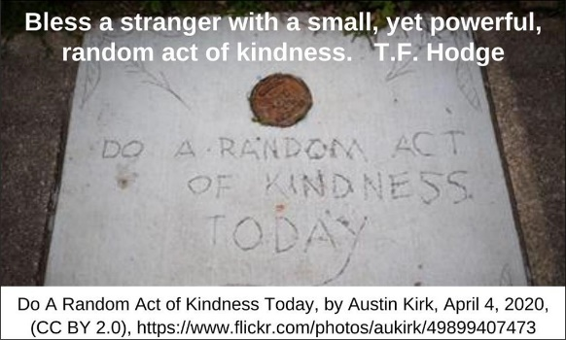

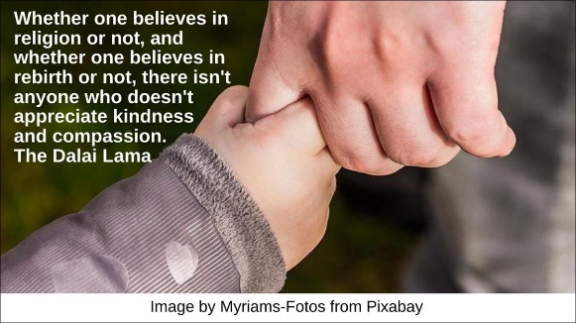

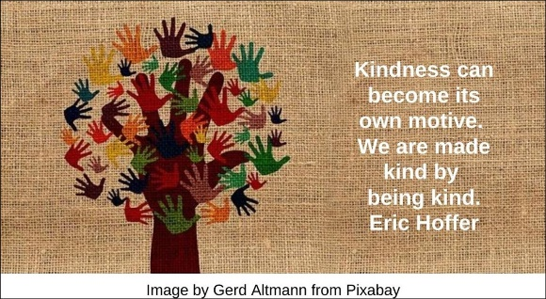

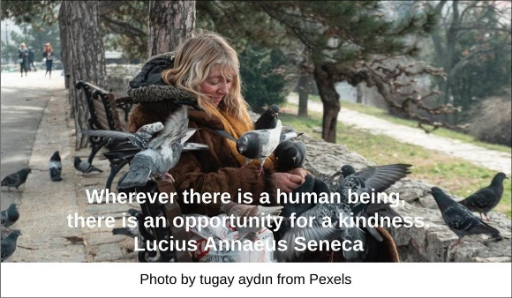

Children HRJ
Compassion HRJ
Dance for Joy HRJ
Enriches HRJ

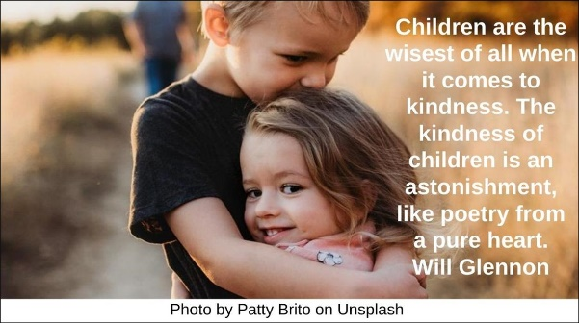





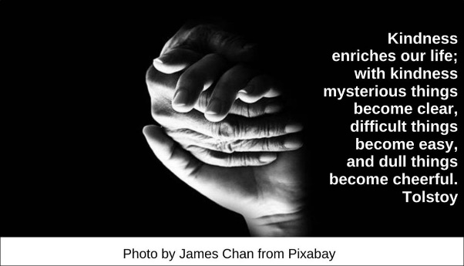

Flower HRJ
Heart Moon HRJ
Heaven HRJ
Hunger HRJ

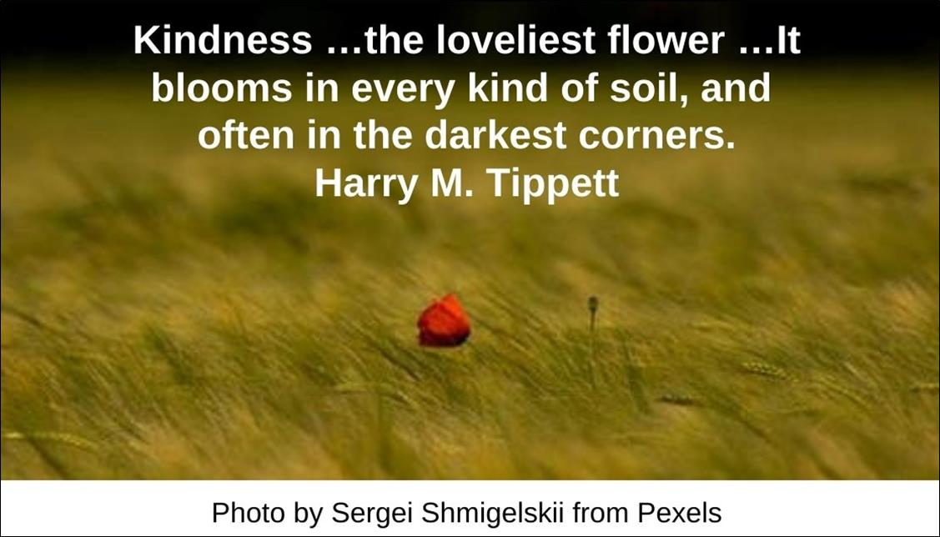



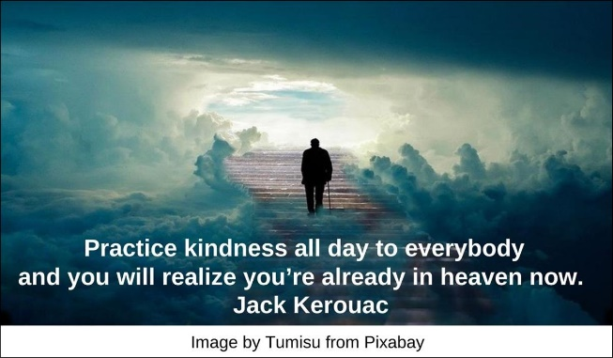

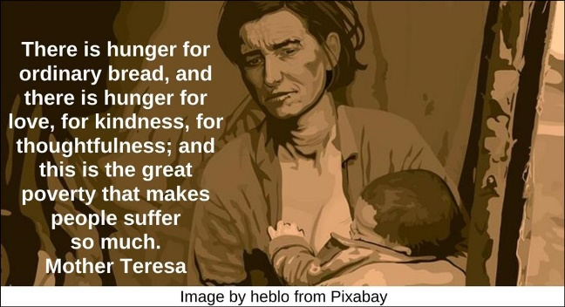

Ice Melting HRJ
Learning Kindness HRJ
Loving and Gentle HRJ
Loving Kindness HRJ

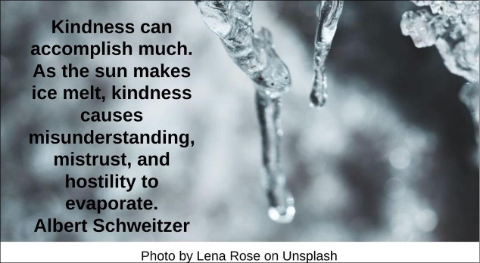

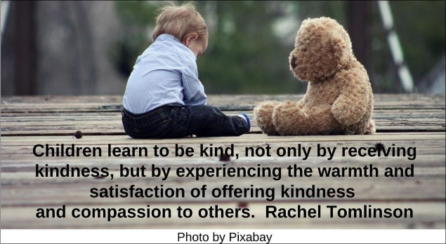

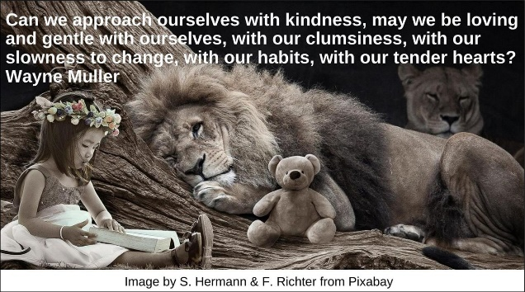

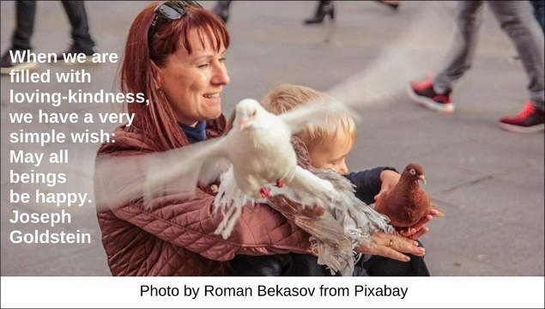

Nice HRJ
Peace HRJ
Practice HRJ
Rainbow Heart HRJ

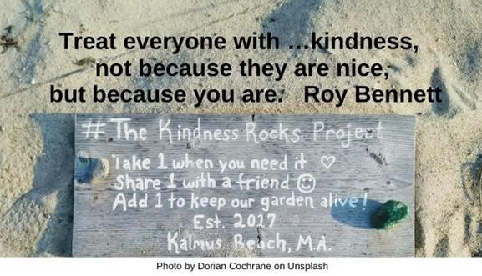

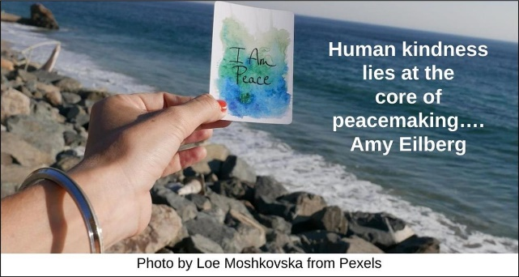

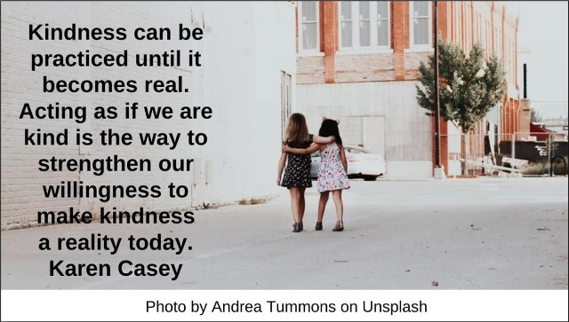



Random Act HRJ
Rebel HRJ
Regret HRJ
Roots HRJ

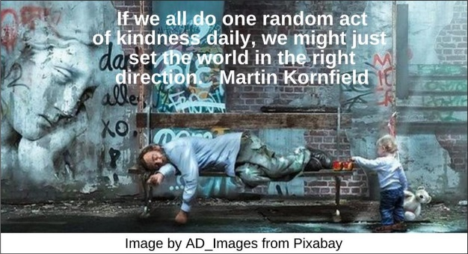

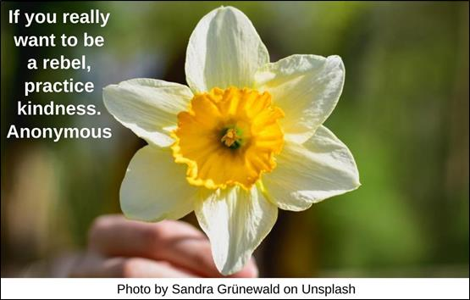

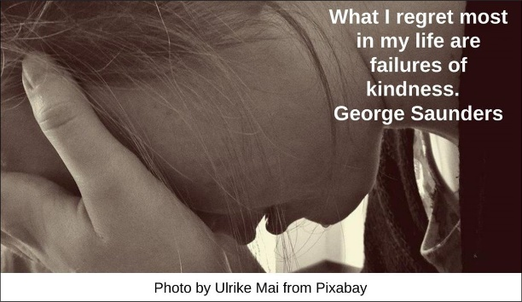

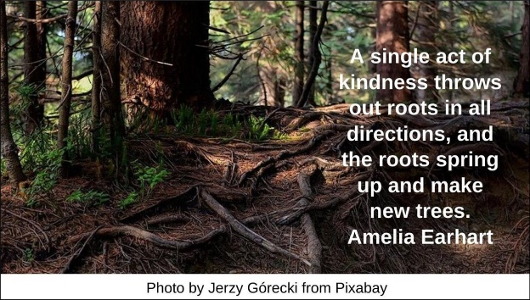

Sell By HRJ
Small HRJ
Sontag HRJ
Too Late HRJ

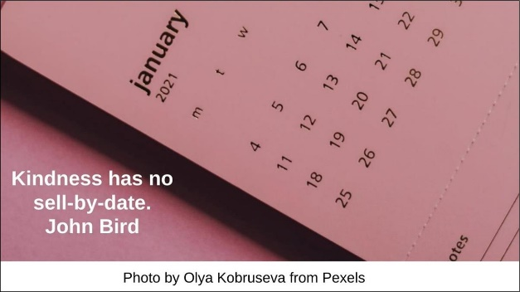

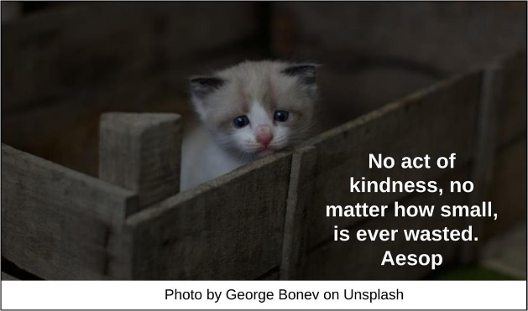



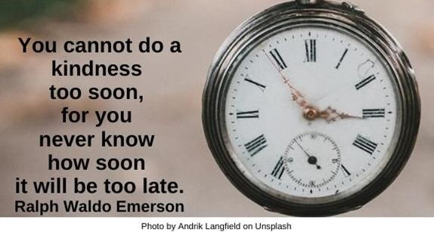

Vulnerable HRJ
Wisdom HRJ
Wonder HRJ

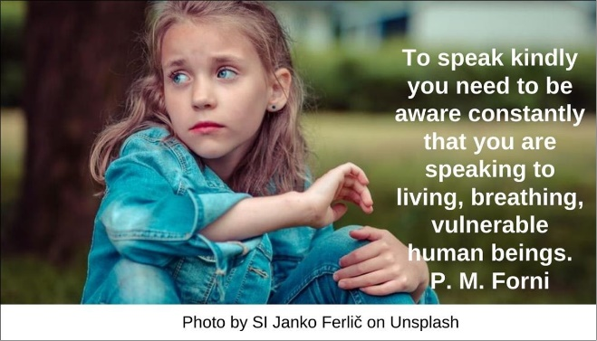



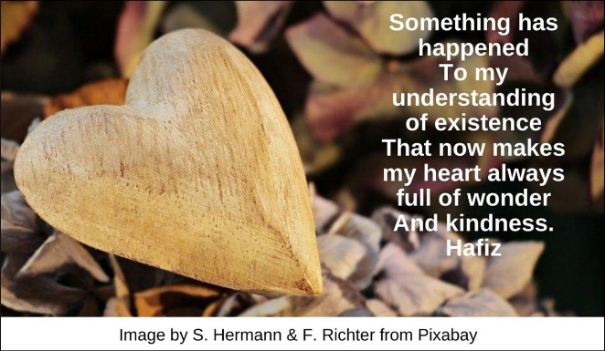

Text of Quotes
Act of Kindness HRJ
Bless a stranger with a small, yet powerful, random act of kindness. T.F. Hodge

Appreciate HRJ
Whether one believes in religion or not, and whether one believes in rebirth or not, there isn't anyone who doesn't appreciate kindness and compassion. The Dalai Lama

Being Kind HRJ
Kindness can become its own motive. We are made kind by being kind. Eric Hoffer

Birds HRJ
Wherever there is a human being, there is an opportunity for a kindness. Lucius Annaeus Seneca

Children HRJ
Children are the wisest of all when it comes to kindness. The kindness of children is an astonishment, like poetry from a pure heart. Will Glennon

Compassion HRJ
Compassion is literally feeling-with, or being-with. We are first and foremost fellow-humans. Mitsein. Kinfolk. Kindred flesh. It is this radical fellow-feeling that creates the impulse that flowers into kindness. Sam Keen

Dance for Joy
Any eye can threaten…., or …insult….; or in its altered mood, [its] beams of kindness …can make the heart dance for joy. Ralph Waldo Emerson

Enriches HRJ
Kindness enriches our life; with kindness mysterious things become clear, difficult things become easy, and dull things become cheerful. Tolstoy

Flower HRJ
Kindness …the loveliest flower …It blooms in every kind of soil, and often in the darkest corners. Harry M. Tippett

Heart Moon HRJ
Our acts of kindness … return us once again to the heart of our own humanity. Will Glennon

Heaven HRJ
Practice kindness all day to everybody and you will realize you’re already in heaven now. Jack Kerouac

Hunger HRJ
There is hunger for ordinary bread, and there is hunger for love, for kindness, for thoughtfulness; and this is the great poverty that makes people suffer so much. Mother Teresa

Ice Melting HRJ
Kindness can accomplish much. As the sun makes ice melt, kindness causes misunderstanding, mistrust, and hostility to evaporate. Albert Schweitzer

Learning Kindness HRJ
Children learn to be kind, not only by receiving kindness, but by experiencing the warmth and satisfaction of offering kindness and compassion to others. Rachel Tomlinson

Loving and Gentle HRJ
Can we approach ourselves with kindness, may we be loving and gentle with ourselves, with our clumsiness, with our slowness to change, with our habits, with our tender hearts? Wayne Muller

Loving Kindness HRJ
When we are filled with loving-kindness…, we have a very simple wish: May all beings be happy. Joseph Goldstein
Nice HRJ
Treat everyone with …kindness, not because they are nice, but because you are. Roy Bennett

Peace HRJ
Human kindness lies at the core of peacemaking…. Amy Eilberg

Practice HRJ
Kindness can be practiced until it becomes real. Acting as if we are kind is the way to strengthen our willingness to make kindness a reality today. Karen Casey

Rainbow Heart HRJ
We ask a heart of compassion and gentle hands and kindly words. Albert Schweitzer

Random Act HRJ
If we all do one random act of kindness daily, we might just set the world in the right direction. Martin Kornfield

Rebel HRJ
If you really want to be a rebel, practice kindness. Anonymous

Regret HRJ
What I regret most in my life are failures of kindness. George Saunders

Roots HRJ
A single act of kindness throws out roots in all directions, and the roots spring up and make new trees. Amelia Earhart

Sell By HRJ
Kindness has no sell-by-date. John Bird

Small HRJ
No act of kindness, no matter how small, is ever wasted. Aesop

Sontag HRJ
Kindness, kindness, kindness. Susan Sontag, diary entry, January 1, 1972

Too Late HRJ
You cannot do a kindness too soon, for you never know how soon it will be too late. Ralph Waldo Emerson

Vulnerable HRJ
To speak kindly you need to be aware constantly that you are speaking to living, breathing, vulnerable human beings. P. M. Forni

Wisdom HRJ
The highest wisdom is kindness. Berakot

Wonder HRJ
Something has happened
To my understanding of existence
That now makes my heart always full of wonder
And kindness. Hafiz

